Project reported on

**Daily Delight**

**Submitted in partial fulfillment of the requirements for the degree of**

**“Bachelor of Computer Applications”**

**Sem-5 (Year 2025-2026)**

**Submitted By**

**Zala Komal Jaysukhbhai .(230801703)**

**Guided By**

Mr. Bharat Pipaliya AND Mr. Rahulkumar Bagda ,

**A PROJECT SUBMITTED TO**



**Faculty of Science**

**Department of Computer Science**

**Atmiya University**

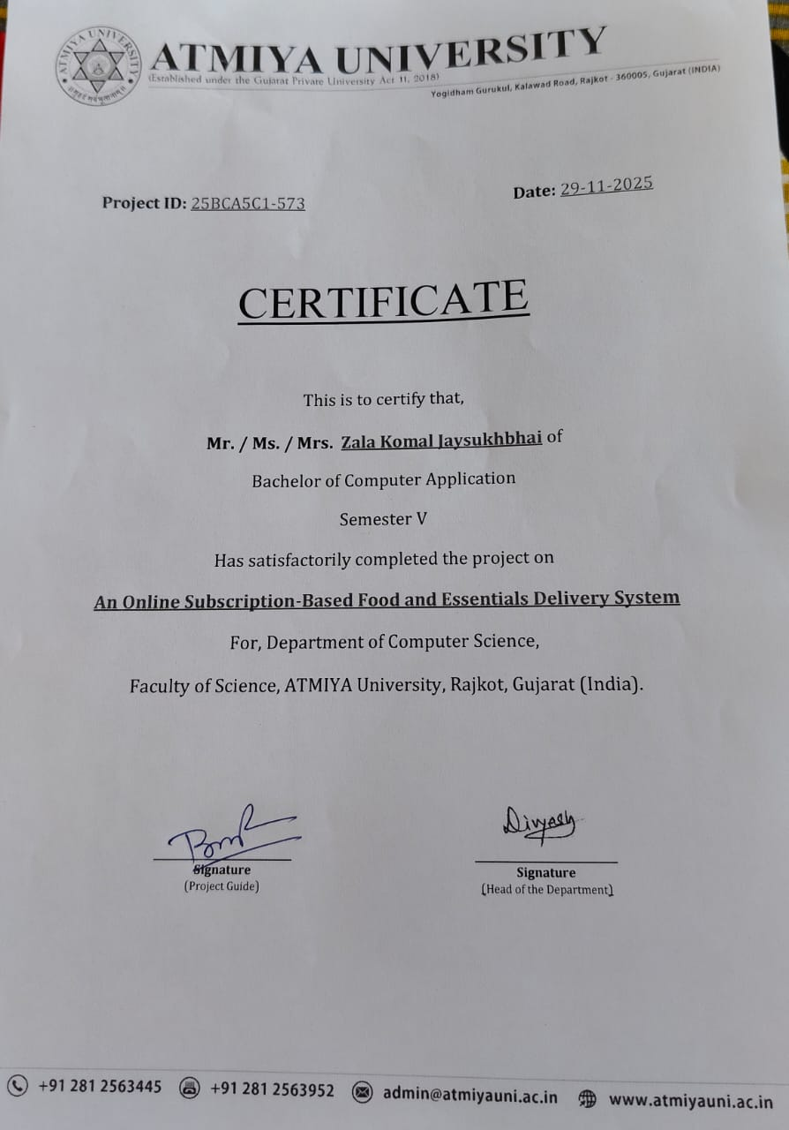

**DECLARATION**

I, hereby declare that the project work entitled **“Daily Delight”** is the original work done by me, and I further declare that it is never submitted anywhere else in part or in full.

- Zala Komal

[Enroll no: 230801703]

**ACKNOWLEDGMENT :-**

**We would like to express our sincere gratitude to everyone who**

**supported and helped us in completing the “Daily Delight” project.**

**This project would not have been possible without their guidance**

**and encouragement.**

**We are thankful to our mentors and advisors, Mr. Bharat Pipaliya**

**and Mr. Rahulkumar Bagda, for their valuable guidance and support**

**throughout the project.**

**We would also like to thank our family and friends for always**

**supporting and motivating us during the project work.**

**Finally, we thank everyone who directly or indirectly helped us in**

**successfully completing this project.**

**– Zala Komal**

**ABSTRACT :-**

* The project **“Daily Delight”** is an online shopping system developed to make daily grocery purchasing easier, faster, and more accessible for users. Instead of visiting a physical store, users can browse available products, add items to their cart, and place orders online from anywhere at any time.
* The system is designed using **PHP** for backend processing and **MySQL** for secure and efficient data storage. The frontend is built using **HTML, CSS, and JavaScript**, which provide a responsive and user-friendly interface, ensuring smooth navigation and an enhanced shopping experience. The platform is tested and hosted locally using **XAMPP** and managed through **phpMyAdmin**.
* The main purpose of this project is to digitalize daily shopping and reduce time and effort for users. This project also supports product management, user login, order handling, and database-driven functionality that ensures accuracy and efficiency.
* Overall, **Daily Delight** serves as a convenient and modern solution for everyday shopping needs by connecting users with essential items through a simple and reliable web application.

**TABLE OF CONTENTS**

|  |  |  |
| --- | --- | --- |
| **Sr. No.** | **Chapter Title** | **Page no** |
| **CHAPTER 1 : INTRODUCTION** | |  |
| 1.1 | Problem Statement |  |
| 1.2 | Project Scope |  |
| 1.3 | Purpose |  |
| **CHAPTER 2 : REQUIREMENTS AND ANALYSIS** | |  |
| 2.1 | System Analysis |  |
| 2.2 | Software and Hardware Requirements |  |
| **CHAPTER 3 : PROJECT PLANNING AND SCHEDULING** | |  |
| **CHAPTER 4 : SYSTEM DESIGN** | |  |
| 4.1 | Logical Design |  |
|  | 4.1.1Data flow diagram (DFD) |  |
|  | 4.1.2 ER Diagram |  |
|  | 4.1.3 Use Case Diagram |  |
|  | 4.1.4 Module Design |  |
|  | 4.1.5 Data Dictionary |  |
| **CHAPTER 5 :SCREENLAYOUT AND TESTING** | |  |
| 5.1 | Screen Layout |  |
|  | 5.1.1 Admin Side |  |
|  | 5.1.2 User Side |  |
| 5.2 | Testing Approach |  |
| **CHAPTER 6 : SYSTEM SECURITY AND MEASURES** | |  |
| **CHAPTER 7 : FUTURE SCOPE AND ENHANCEMENT** | |  |
| **CHAPTER 8 : CONCLUSION AND LIMITATIONS** | |  |
| **CHAPTER 9 : BIBLIOGRAPHY** | |  |

**CHAPTER 1 : INTRODUCTION**

**1.1 Problem Statement ::**

In today’s fast-paced lifestyle, people often struggle to find time to visit physical stores for daily groceries and essential items. Traditional shopping requires travel, waiting in queues, and checking product availability manually, which becomes inconvenient and time-consuming.

Although online shopping platforms exist, many users still hesitate to shop online due to **lack of trust**, fake products, poor quality, hidden charges, and unreliable delivery services. Because of these issues, customers cannot fully rely on online stores for their essential daily needs.

There is a need for a **trusted, reliable, and user-friendly online platform** where users can browse products, check accurate pricing, and place secure orders without worrying about product quality or delivery issues. At the same time, shop owners should have a simple system to manage products, update prices, and handle customer orders efficiently.

The **Daily Delight** project is developed to solve these problems by providing a safe, trusted, and convenient digital shopping experience. It aims to make daily grocery shopping easier, quicker, and more reliable for both customers and store owne

**1.2 Project Scope ::**

The **Daily Delight** project focuses on creating a reliable and user-friendly online shopping platform where customers can purchase daily essential items easily and securely. The system allows users to browse products, add items to their cart, and place online orders from the comfort of their home.

This project covers key features such as product listing, category-based browsing, secure user login, shopping cart management, and order confirmation. It also includes an admin panel where the store owner can manage products, update stock, change prices, and view customer orders.

The platform aims to provide a trusted online shopping experience by displaying accurate information, maintaining secure data storage, and ensuring smooth functionality. The project is designed to be scalable, meaning more features like online payment, delivery tracking, and customer reviews can be added in the future.

Overall, the scope of **Daily Delight** is to offer a modern, convenient, and reliable solution for online grocery shopping that benefits both customers and store administrators.

**1.3 Purpose ::**

The purpose of the **Daily Delight** project is to provide a convenient and trusted online platform where users can purchase daily grocery items without visiting a physical store. The system is designed to save time, reduce effort, and make shopping easier for customers by allowing them to browse, select, and order products from anywhere.

This project also aims to help shop owners manage their store digitally by allowing them to update product details, check orders, and maintain stock efficiently. By creating a secure and user-friendly interface, the system helps customers feel confident and safe while shopping online.

Overall, the main purpose of **Daily Delight** is to create a simple, reliable, and modern online shopping experience that benefits both customers and store administrators.

**CHAPTER 2 : REQUIREMENTS AND ANALYSIS**

**2.1 System Analysis ::**

System analysis is the process of studying and understanding the current system to identify problems, user needs, and the requirements for developing a better solution. In this project, system analysis helps in understanding how the **Daily Delight** online shopping system should work and what features are needed to improve the shopping experience.

During system analysis, both the customer’s needs and the admin’s responsibilities were studied. Customers need a platform where they can easily browse products, add items to their cart, and order them online without facing trust issues or confusion. On the other hand, the admin needs a system where they can manage product details, update prices, check orders, and keep track of stock efficiently.

The analysis also includes the study of security, performance, user interface, and database requirements. This helps ensure that the final system is user-friendly, secure, and efficient.

Through this system analysis, the main issues of traditional shopping and existing online platforms were identified, such as lack of trust, time consumption, and manual work. Based on these findings, the **Daily Delight** system was planned to provide a modern, reliable, and easy online shopping solution.

**2.2 Software and Hardware Requirements ::**

To successfully develop and run the **Daily Delight** system, certain hardware and software resources are required. These requirements help ensure smooth functionality, efficient processing, and a user-friendly experience. The following specifications were selected based on system needs, performance requirements, and compatibility with the technologies used.

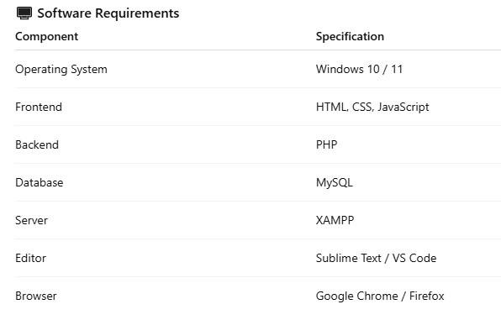

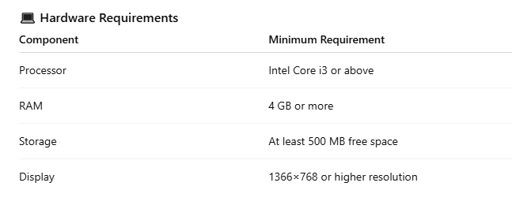

**CHAPTER 3 : PROJECT PLANNING AND SCHEDULING**

**3** **: PROJECT PLANNING AND SCHEDULING ::**

**1. Introduction:**  
Project planning and scheduling is the process of organizing tasks, estimating time, and allocating resources to complete the project efficiently. For **Daily Delight**, proper planning ensures smooth development, even as an individual developer.

**2. Planning Objectives:**

* Develop a fully functional and secure grocery shopping website.
* Create a responsive and user-friendly interface.
* Implement a structured database to manage products, users, and orders.
* Ensure timely completion of all modules with proper testing.

**3. Project Tasks and Modules (with Updated Durations):**

| **Task** | **Description** | **Duration (Days)** |
| --- | --- | --- |
| Requirement Analysis | Understanding project requirements and features | 4 |
| Database Design | Designing MySQL database for products, users, orders | 5 |
| Frontend Development | Creating UI using HTML, CSS, JavaScript | 8 |
| Backend Development | Coding PHP scripts for login, cart, orders | 8 |
| Integration | Connecting frontend with backend and database | 4 |
| Testing & Debugging | Checking functionality, fixing errors | 5 |
| Deployment | Setting up on local server (XAMPP) and final testing | 2 |

**4. Scheduling Techniques:**

* **Gantt Chart:** Shows tasks along a timeline with start and end dates.
* **Timeline Planning:** Ensures dependencies are respected, e.g., database must be ready before backend integration.

**5. Example Timeline (Weeks):**

| **Week** | **Tasks** |
| --- | --- |
| Week 1 | Requirement Analysis + Database Design |
| Week 2 | Frontend Development |
| Week 3 | Frontend Development + Backend Development |
| Week 4 | Backend Development + Integration |
| Week 5 | Testing & Debugging |
| Week 6 | Deployment |

**6. Benefits of Planning & Scheduling:**

* Helps a solo developer manage time and tasks effectively.
* Prevents delays and confusion during development.
* Ensures all project modules are completed systematically.
* Improves overall project quality by following a structured workflow.

**7. Tools for Planning:**

* Microsoft Excel / Google Sheets (for Gantt chart)
* Manual timeline charts

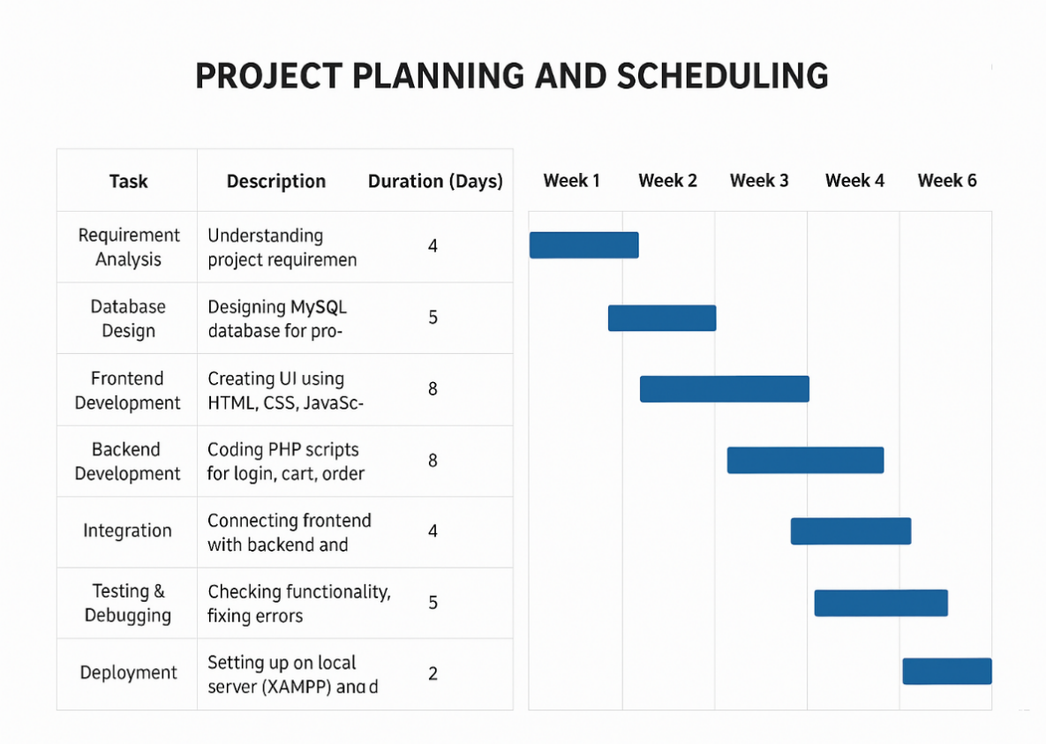

The image shows a Gantt Chart used for project planning and scheduling. It outlines key development tasks such as requirement analysis, database design, frontend and backend development, integration, testing, and deployment. Each task is assigned a time duration and positioned on a weekly timeline. The chart also shows overlapping activities to improve efficiency and reduce project duration. This planning helps track progress, manage time effectively, and ensure the project is completed in an organized manner.

**CHAPTER 4 : SYSTEM DESIGN**

**4.1 Logical Design ::**

**4.1 . 1Data flow diagram (DFD) ::**

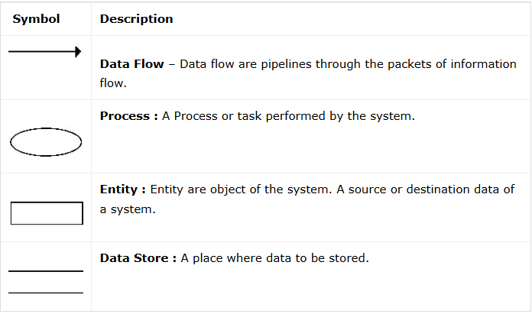

**0 level ::**

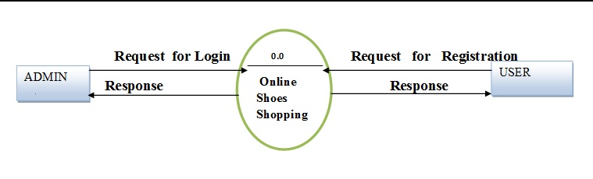

**Daily Delight**

**1 level ::**

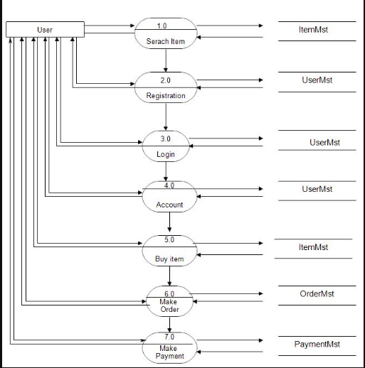

**4.1.2 ER Diagram ::**

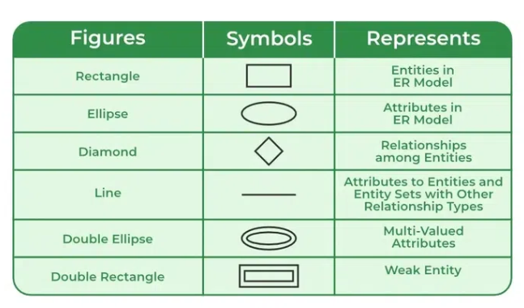

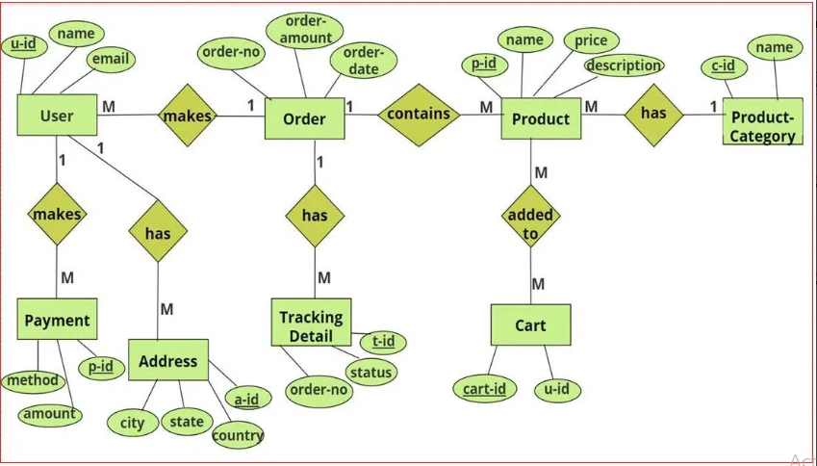

**4.1.3 Use Case Diagram ::**

**User Side ::**

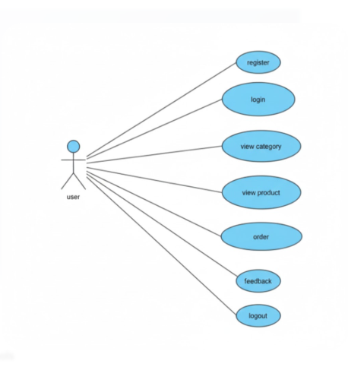

**Admin Side ::**

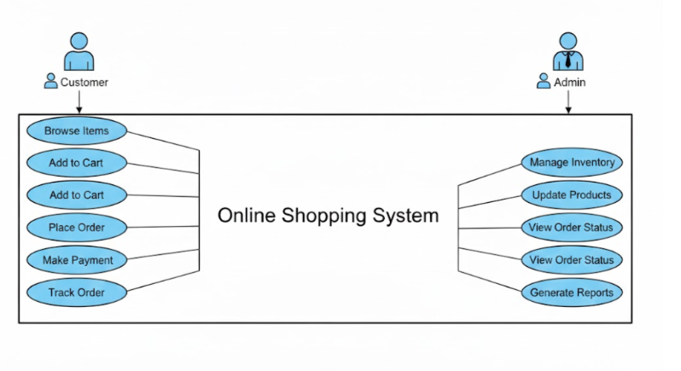

**4.1.4 Module Design on my project ::**

The module design of the Daily Delight online shopping system defines how the application is divided into manageable and functional units. Each module is responsible for handling specific functionality and interacts smoothly with other modules to provide a seamless shopping experience. The modular structure improves system scalability, code reusability, and maintenance efficiency. It also allows developers to modify or update one module without affecting the overall system functionality.

The system consists of modules such as User Management, Product Catalog, Shopping Cart, Order and Payment Processing, Review System, and Admin Panel. These modules communicate with each other through defined interfaces and share common data stored in the database

#### **Characteristics of Module Design**

* Ensures independent development of each module
* Reduces complexity and increases system flexibility
* Allows upgrading individual modules without affecting others
* Enhances maintainability and debugging efficiency
* Supports future scalability with additional modules

**Module Description Table ::**

| **Module Name** | **Functionality** | **User Type** |
| --- | --- | --- |
| **User Management Module** | Handles user registration, login, authentication, and profile updates. | Customer / Admin |
| **Product Catalog Module** | Displays product details, categories, offers, and manages product search. | Customer |
| **Shopping Cart Module** | Allows users to add, update, or remove products before checkout. | Customer |
| **Order & Payment Module** | Processes orders, generates order summary, and handles online or COD payments. | Customer |
| **Review & Rating Module** | Allows users to rate and write feedback for purchased products. | Customer |
| **Admin Management Module** | Admin can manage products, users, orders, and system configurations. | Admin |

----------------------------------------------------------------------------------------------------------

1. **User Management Module** – Manages user registration, login, and profile details.
2. **Product Catalog Module** – Displays available products with category and search options.
3. **Shopping Cart Module** – Stores selected items for the user before final checkout.
4. **Order & Payment Module** – Handles order placement, billing, and payment transactions.
5. **Review & Rating Module** – Allows customers to submit reviews and rate purchased products.
6. **Admin Management Module** – Enables admin to manage users, products, orders, and system reports.

**4.1.5 Data Dictionary ::**

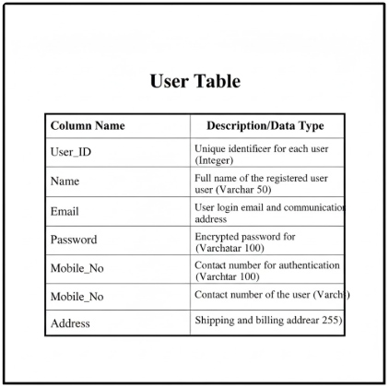

----------------------------------------------------------------------------------------------------------

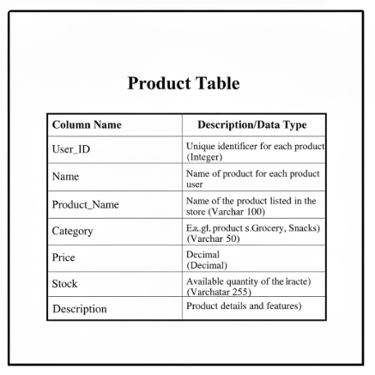

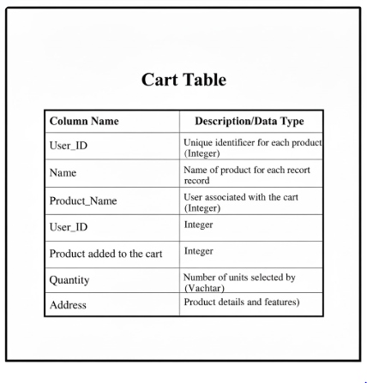

----------------------------------------------------------------------------------------------------------

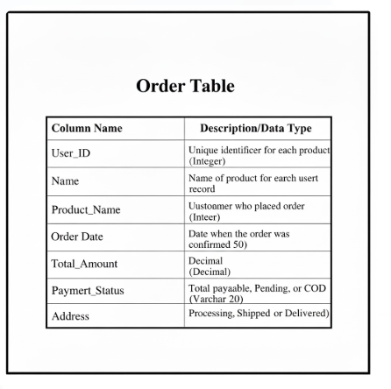

----------------------------------------------------------------------------------------------------------

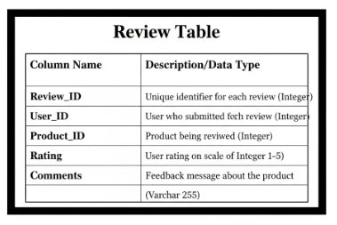

**CHAPTER 5 :SCREENLAYOUT AND TESTING**

**5.1 Screen Layout ::**

**5.1.1 Admin Side ::**

* **Admin Dashboard**

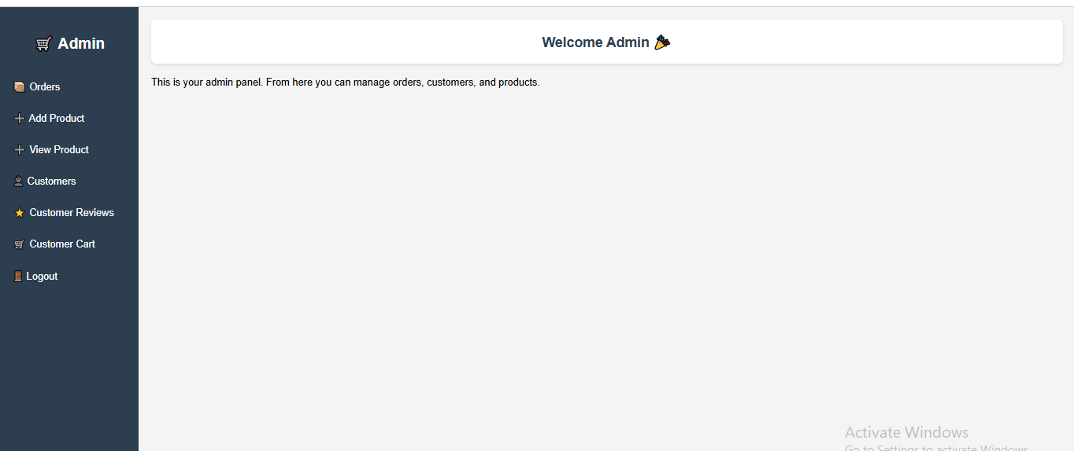

* **Orders**

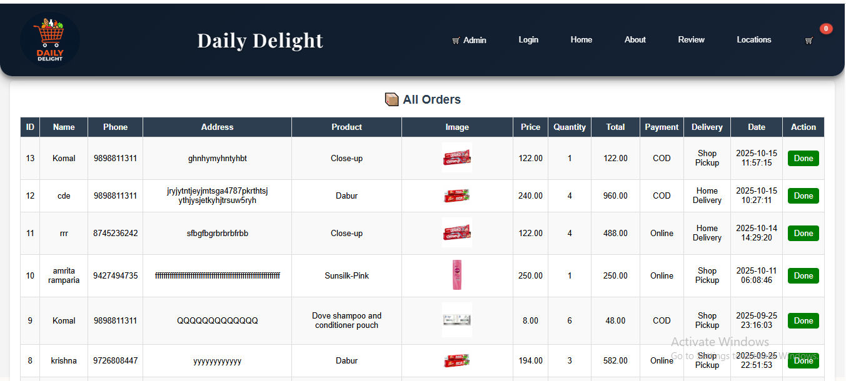

* **Add Categories ::**

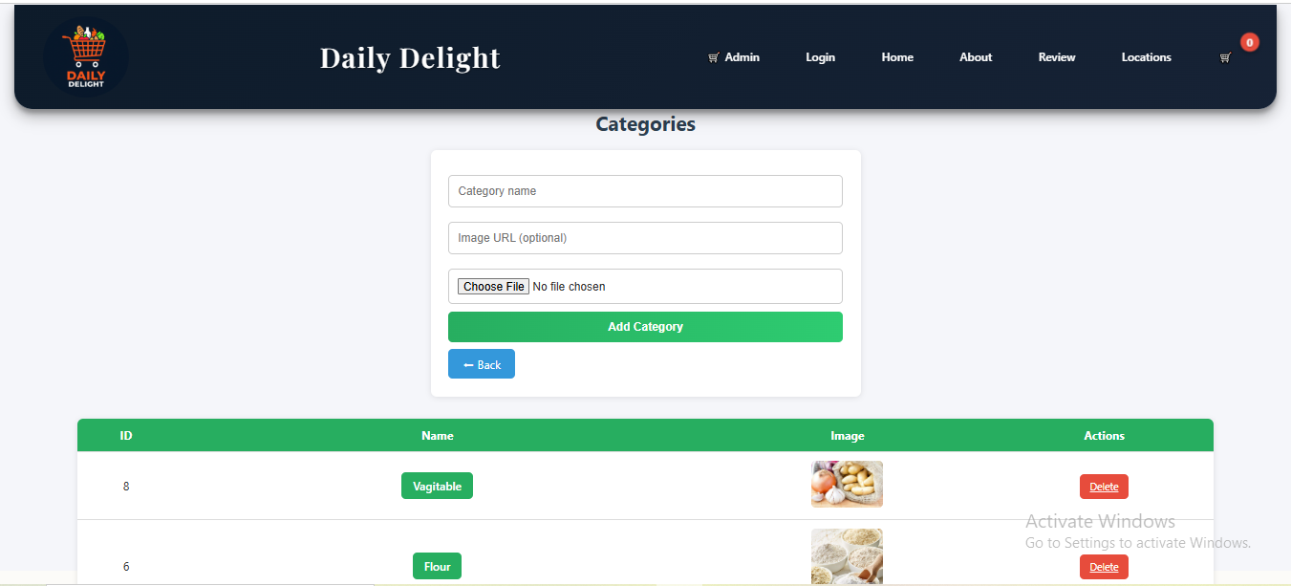

* **All Registered Customer :**

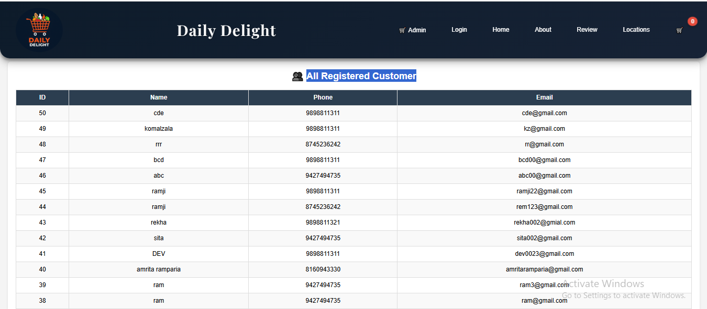

* **Customer Reviews ::**



* **Edit Product ::**

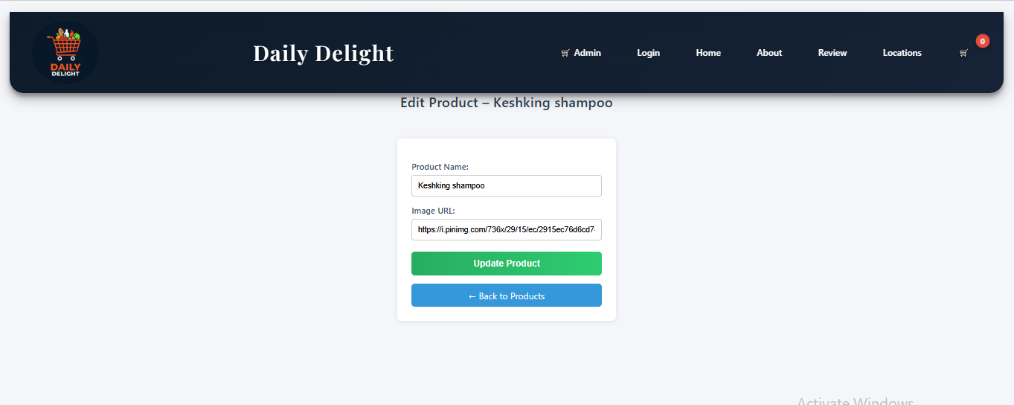

* **Add Or Remove Produc**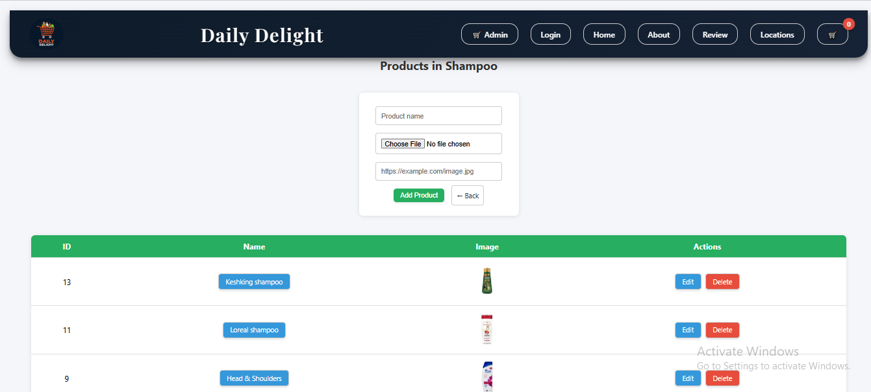
  + 1. **User Side ::**
* **Login Page ::**

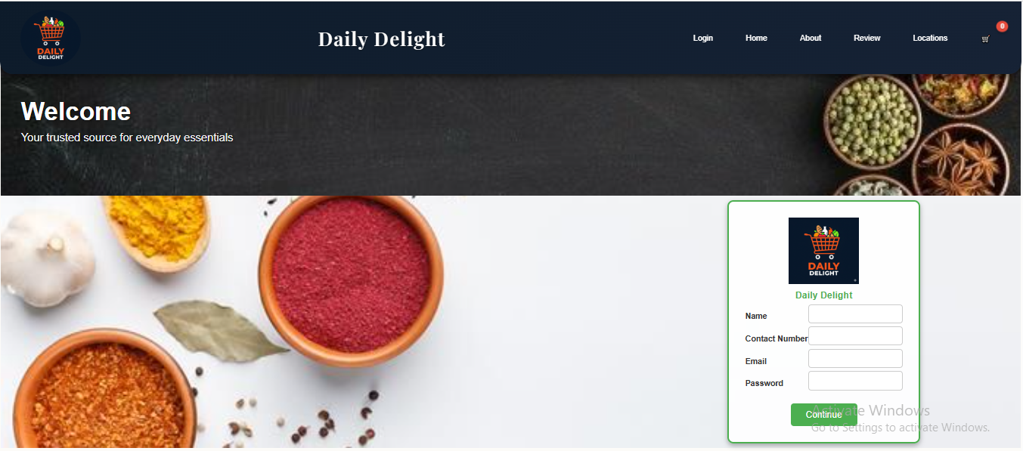

* **Product List ::**

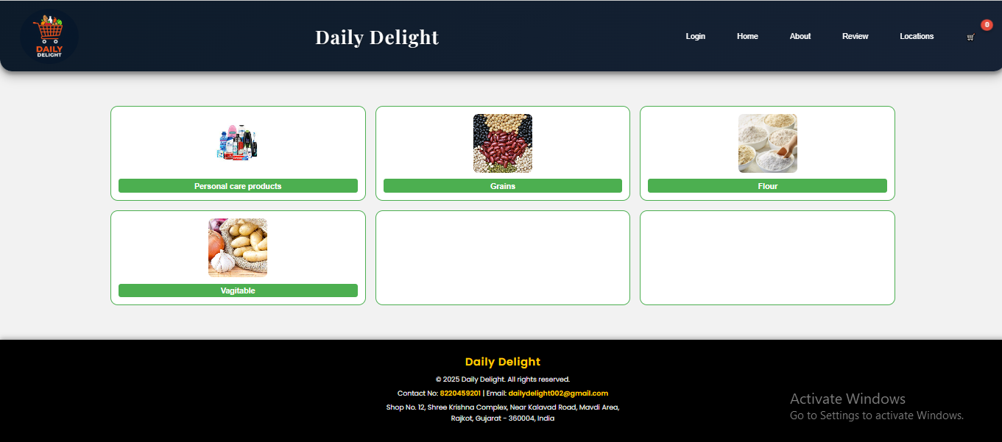

* **SubCategori page ::**

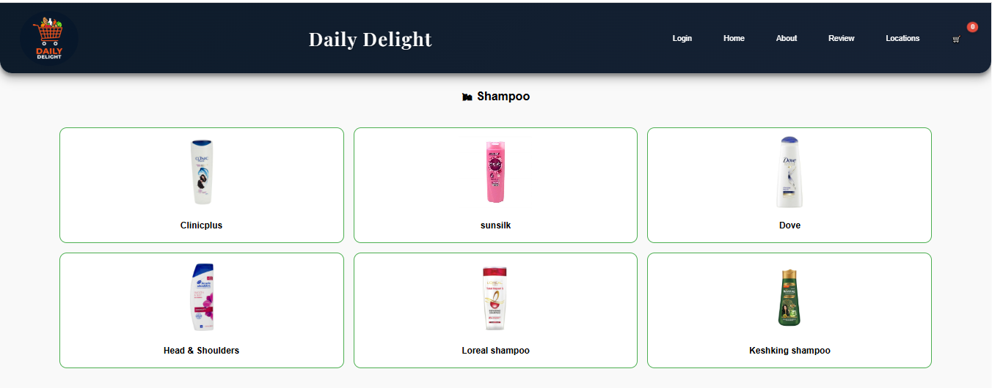

* **Product Detail :**

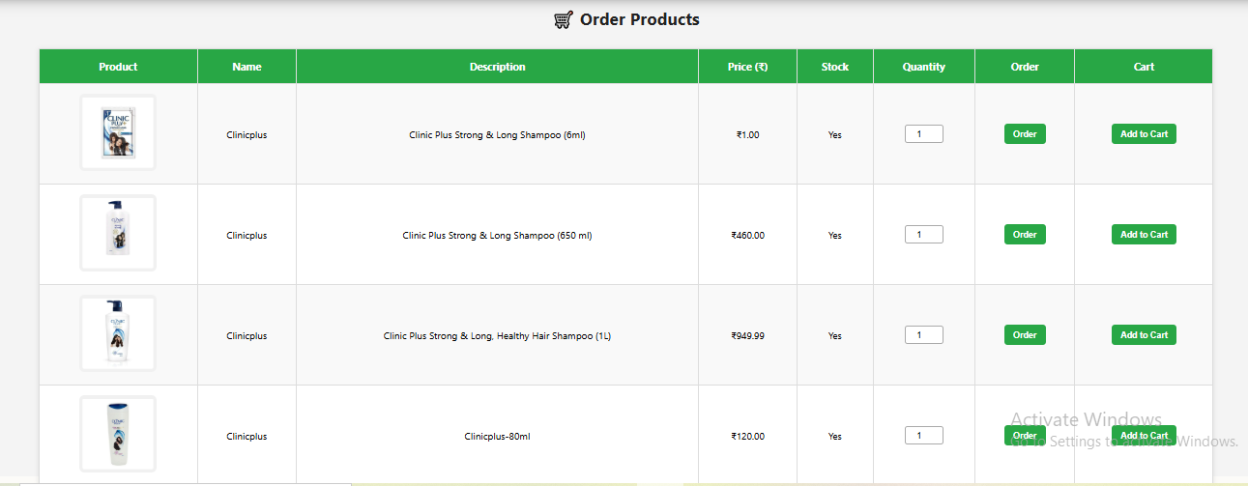

* **Cart Page ::**

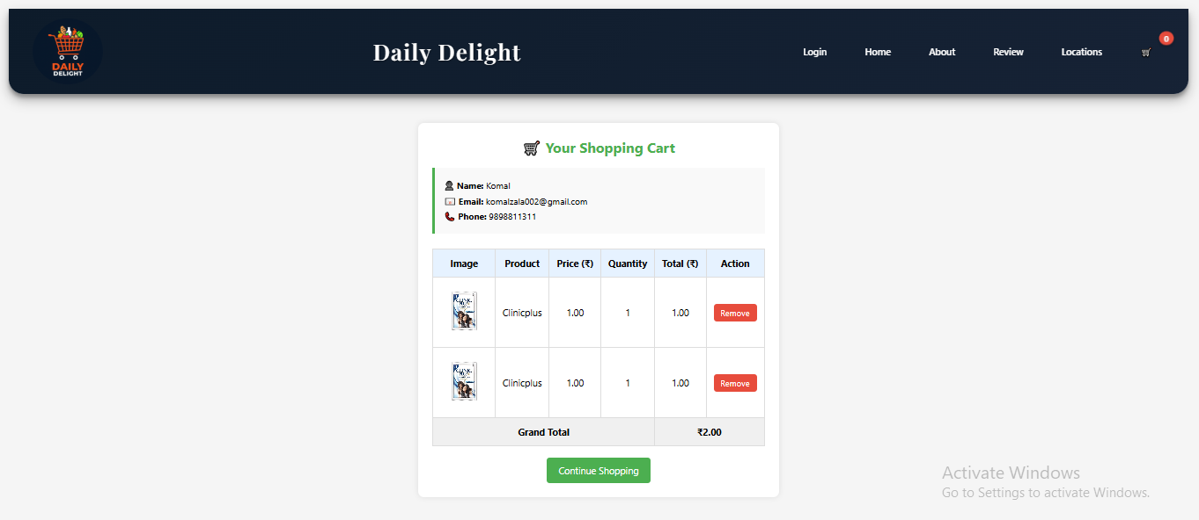

* **Order Page ::**

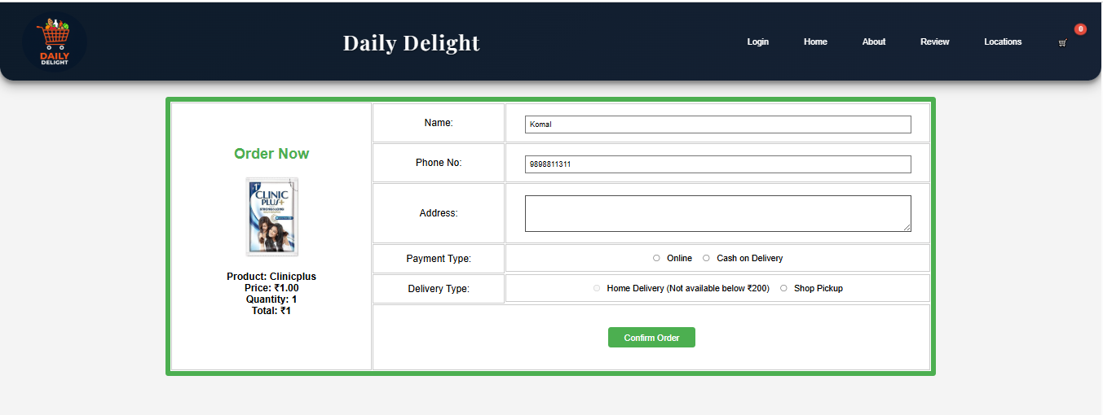

* **Location ::**

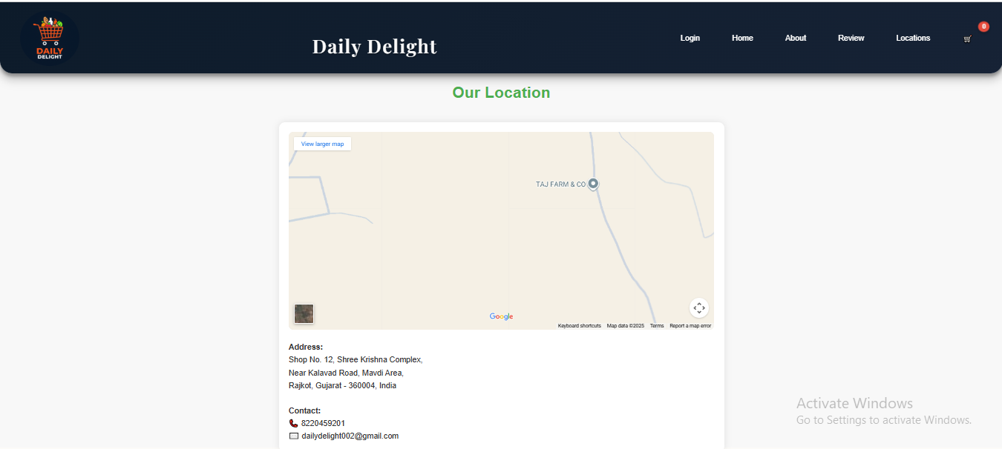

* **About US ::**

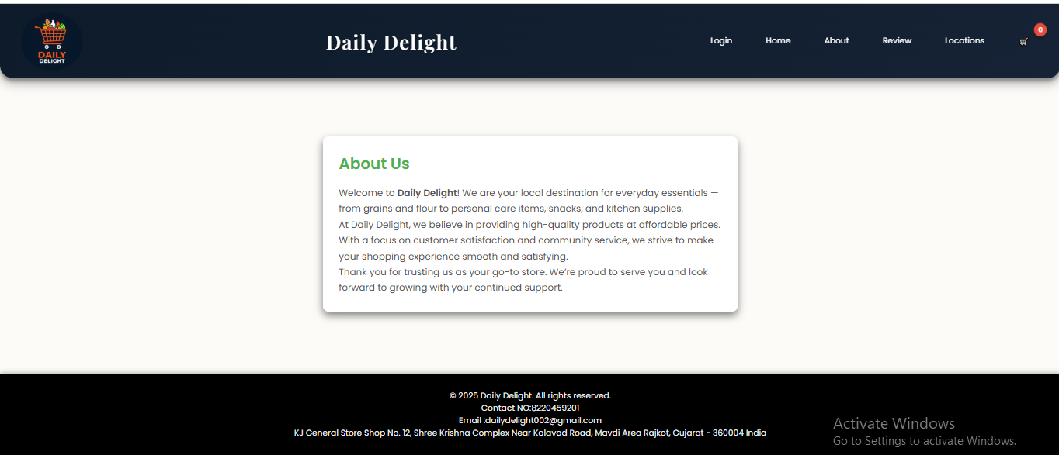

* 1. **Testing Approach ::**

Testing is a systematic process to evaluate the functionality, reliability, and performance of the system. The main goal is to ensure that the Daily Delight online shopping system meets all user requirements and functions smoothly without errors. The testing approach defines how different testing types are planned, executed, and documented.

### ****1. Types of Testing****

1. **Unit Testing**
   * Tests individual modules like User Management, Product Management, Cart, Order & Payment, and Admin Panel separately.
   * Ensures each module performs its intended function correctly.
2. **Integration Testing**
   * Checks if different modules work together seamlessly.
   * Example: Verifying that adding a product to the cart updates the cart total correctly and is reflected in the order processing module.
3. **Functional Testing**
   * Ensures all functionalities meet the defined requirements.
   * Example: Searching for a product, placing an order, and processing payment.
4. **System Testing**
   * Tests the complete system as a whole in an environment similar to deployment.
   * Verifies the workflow from browsing products to completing payment.
5. **User Acceptance Testing (UAT)**
   * Conducted by real users to ensure the system satisfies business and user requirements.
   * Ensures that the system is user-friendly and ready for live deployment.
6. **Security Testing**
   * Ensures that sensitive data like passwords, payment information, and user details are secure.
   * Tests include authentication, role-based access, and data protection.
7. **Performance Testing**
   * Measures system response time, load handling, and stability under different conditions.
   * Ensures that the website performs efficiently even with multiple concurrent users.

### ****2. Testing Life Cycle****

1. **Requirement Analysis** – Understand functional and non-functional requirements.
2. **Test Planning** – Decide testing scope, strategy, resources, and schedule.
3. **Test Design** – Prepare test cases, test data, and expected results.
4. **Test Execution** – Run the tests on different modules and record outcomes.
5. **Defect Reporting** – Log any errors or bugs detected during testing.
6. **Retesting & Regression Testing** – Verify fixes and ensure no new errors are introduced.
7. **Final Approval** – System is approved for deployment after passing all test cases.

### ****3. Benefits of this Testing Approach****

* Detects defects early, reducing maintenance cost.
* Ensures the system meets all functional and non-functional requirements.
* Provides confidence in system performance and reliability.
* Improves user satisfaction and reduces post-deployment errors.

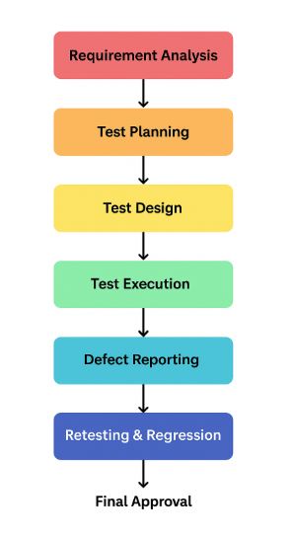

**CHAPTER 6 : SYSTEM SECURITY AND MEASURES**

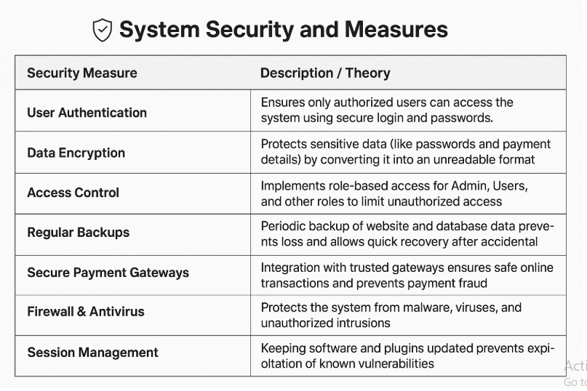

**System Security and Measures** ensures that computer systems and networks are protected from unauthorized access, attacks, and data breaches. It involves implementing safeguards such as firewalls, antivirus software, and intrusion detection systems to maintain data confidentiality, integrity, and availability. Regular system updates and patches are necessary to fix vulnerabilities and prevent exploitation. Strong user authentication methods, like passwords, biometrics, and multi-factor authentication, enhance security. Access control policies ensure that only authorized personnel can access sensitive information. Backup and recovery procedures help in restoring data in case of system failures or attacks. Overall, effective system security measures create a safe computing environment, minimizing risks and ensuring smooth operations.

**CHAPTER 7 : FUTURE SCOPE AND ENHANCEMENT**

**FUTURE SCOPE AND ENHANCEMENT ::**

• **Expand Product Range:** Include more categories like fresh vegetables, fruits, bakery items, dairy products, beverages, personal care, and household essentials to cater to wider customer needs.

• **AI and Personalized Recommendations:** Implement AI and machine learning to analyze user behavior and purchase history, providing personalized suggestions and enhancing customer satisfaction.

• **Mobile Application Development:** Develop a mobile app to allow users to shop anytime, anywhere, increasing accessibility and convenience.

• **Advanced Analytics:** Use data analytics to monitor customer behavior, optimize inventory, forecast demand, and make strategic business decisions.

• **Secure and Multiple Payment Options:** Integrate multiple payment gateways, UPI, and digital wallets to provide secure, fast, and hassle-free transactions.

• **Real-Time Delivery Tracking and Notifications:** Add features like live delivery tracking, automated alerts, and notifications to improve transparency and customer service.

• **Cloud Technology Integration:** Adopt cloud infrastructure to make the platform scalable, reliable, and capable of handling high traffic loads.

• **Continuous Updates and Enhancements:** Regularly update features, security measures, and the user interface to improve usability, performance, and competitiveness.

• **Customer Engagement and Loyalty Programs:** Introduce reward points, referral programs, and social media integration to enhance customer retention and brand loyalty.

• **Innovative Features:** Plan for future additions like voice-assisted shopping, AR-based product previews, subscription services, and automated inventory management to stay competitive.

• **Sustainability and Green Initiatives:** Implement eco-friendly packaging options and support local suppliers to promote sustainability and corporate social responsibility.

• **Expansion of Delivery Services:** Explore partnerships with local delivery services or develop own logistics for faster, efficient, and wider coverage.

**CHAPTER 8 : CONCLUSION AND LIMITATIONS**

**CONCLUSION AND LIMITATIONS ::**

* **Conclusion:**
* The “Daily Delight” project provides a convenient and interactive online grocery shopping platform, making shopping easier for customers. It allows seamless browsing of products and smooth order placement.
* Customers can make secure online payments, ensuring safe and hassle-free transactions for a better shopping experience.
* Features like order tracking, automated notifications, and a structured product catalog improve user satisfaction and engagement.
* The system is designed to be scalable, reliable, and secure, supporting smooth operations for both administrators and users.
* It reduces shopping time and effort, enabling customers to access essential items from home efficiently.
* The project lays a strong foundation for future technological enhancements, including more product categories and advanced features.
* Overall, it demonstrates how e-commerce solutions can improve service efficiency and provide a modern, customer-friendly shopping experience.
* **Limitations:**
* The system relies on stable internet connectivity, which may affect uninterrupted operation in areas with poor network access.
* Delivery services are limited to specific regions, restricting the reach of the platform for customers in distant locations.
* Advanced features like AI-based personalized recommendations and mobile app integration are planned but not yet implemented.
* Regular maintenance and software updates are required to ensure continued security, performance, and system efficiency.
* Handling very high traffic may require additional server or cloud infrastructure to prevent slowdowns or downtime.
* Customer support and complaint management functionalities need improvement to manage increasing user demands effectively.
* Integration with third-party logistics and payment systems may occasionally face technical challenges that affect operations.

**CHAPTER 9 : BIBLIOGRAPHY**

### ****BIBLIOGRAPHY ::****

The bibliography section includes all the reference materials, books, websites, tools, and online resources used during the development of the **Daily Delight** project. These resources helped in understanding various technical concepts such as web development, database management, PHP programming, user interface design, and security practices. The collected information supported the planning, designing, coding, and testing process of the system. Proper referencing ensures authenticity, accuracy, and acknowledgement of the original authors and sources.

#### **Books Referenced:**

* “Web Technologies: HTML, CSS, JavaScript” by Uttam K. Roy – Oxford University Press.  
  (Used for learning front-end design and basic web structure concepts.)
* “PHP & MySQL Web Development” by Luke Welling & Laura Thomson – Pearson Education.  
  (Helped in understanding dynamic web development and database connectivity.)
* “Database System Concepts” by Abraham Silberschatz, Henry F. Korth, and S. Sudarshan – McGraw Hill Publication.  
  (Used for building and structuring the database for the project.)
* “E-Commerce: A Managerial Perspective” by Kalakota & Whinston – Pearson.  
  (Referred to understand online shopping models and workflow structures.)

#### **Websites and Online Platforms:**

* www.w3schools.com  
  (Used for learning and referencing HTML, CSS, PHP, and MySQL commands and examples.)
* www.geeksforgeeks.org  
  (Referred for solving backend logic, form handling, and technical documentation.)
* www.mysql.com  
  (Used for database guidelines and SQL syntax support.)
* www.php.net  
  (Official documentation for PHP functions and security handling.)
* www.stackoverflow.com  
  (Used for troubleshooting errors and technical problem-solving during development.)
* **chat.openai.com (ChatGPT)** (for content assistance, formatting, explanation, documentation support, and improving clarity)

#### **Software Tools and Technologies:**

* XAMPP – for local server and database support
* phpMyAdmin – for database handling
* Visual Studio Code / Sublime Text – for coding and project development

